**EE6222 Assignment1 option2**

**ZHANG ZHENGHANG**

**E-mail: ZZHANG062@e.ntu.edu.sg**

**1.TheThresholding Process:**

Otus’s method

The main solution of this method is to find a “K” which can maximize the between-class variance.”K” is a pending value coming from Axis of the gray levels histogram.

By randomly assume the value of “K”, all the pixels can be divided into two parts. It’s easy to obtain the mean and the variance of these two parts.

So we calculate the variance between these two parts(). By trying different value of “K”, we assume the “K” to obtain the maximum of  as the optical threshold.

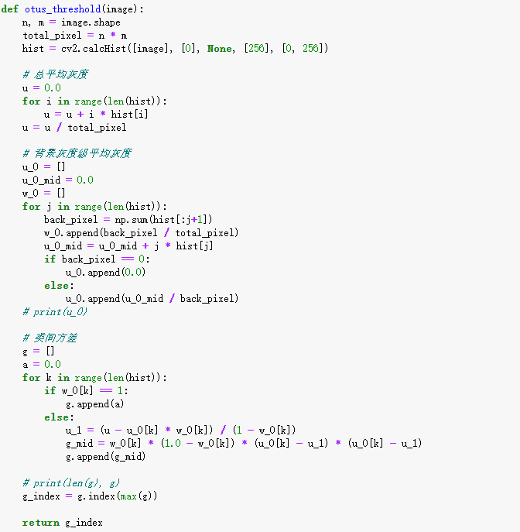

1. **The Thinning Algorithm:**

My thinning code is based on the two-step thinning algorithm introduced in class. In my code, a matrix only consist of “0” and “1” will be processed by ”Zhang_suen_thinning”, “o” means this pixel belong to group ”background” while “1” means “object”.

STEP1:Traverse every pixels, if one pixel meets the following conditions, it will be set to ”0”.(Background)

1. if its value is “1”.
2. 2<=The number of Its non-zero neighbors<=6
3. S=1. S is the the number of 0-1 transition in the ordered sequence of p2,p3,..,p8,p9.
4. At least one of p2,p4,p6 is equal to “0”
5. At least one of p2,p4,p6 is equal to “0”

STEP2:Traverse every pixels, if one pixel meets the following conditions, it will be set to ”0”.(Background)

1. if its value is “1”.
2. 2<=The number of Its non-zero neighbors<=6
3. S=1. S is the the number of 0-1 transition in the ordered sequence of p2,p3,..,p8,p9.
4. At least one of p2,p4,p8 is equal to “0”
5. At least one of p2,p6,p8 is equal to “0”

The steps are repeated until there is no change to all pixels.

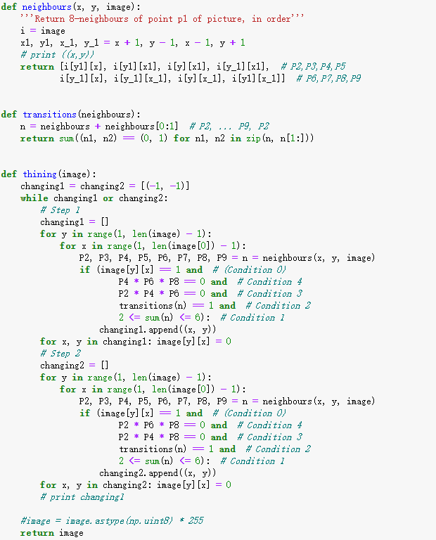

**NOTE:It is necessary to let the processed matrix multiple with 255, or the matrix is still (0,1) binary, which will lead to a all-black image.**

1. **The intermediate and final results:**

**Img1:**

After the thresholding process, the optical “K” is calculated to be set to ”188”.



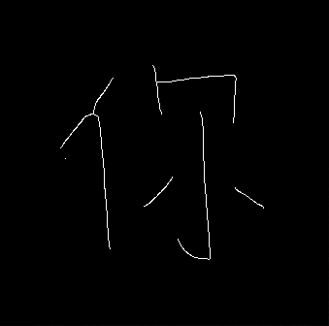

**Img2:**

After the thresholding process, the optical “K” is calculated to be set to ”120”.





**Img3:**

After the thresholding process, the optical “K” is calculated to be set to ”119”.





**Img4:**

After the thresholding process, the optical “K” is calculated to be set to ”208”.





**Img5:**

After the thresholding process, the optical “K” is calculated to be set to ”114”.





**Comment:**

The quality of result is ideal. The thresholding process is very useful, which will reduce the work to find the optical value by different experimental results.

1. **Python code:**

1.read the pending image and translate this image into matrix. The element of this matrix means the gray level of every pixel.(0-255)

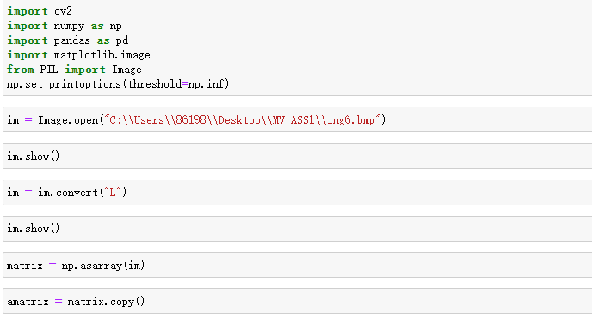

2.Use the optical threshold to translate the above matrix into a (0,1) binary matrix.

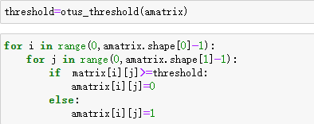

1. show the immediate and final result.

